# Documentation:

## Test - 1 - Straight 5000

### **Other Params:**

Image #: 5000

Epochs: 10

Optimizer: Adam

Loss: Categorical Crossentrpy

### **Structure:**

Conv2D(64, relu)

Conv2D(32)

MaxPool(3,3)

Flatten()

Dense(32, relu)

Dense(3, softmax)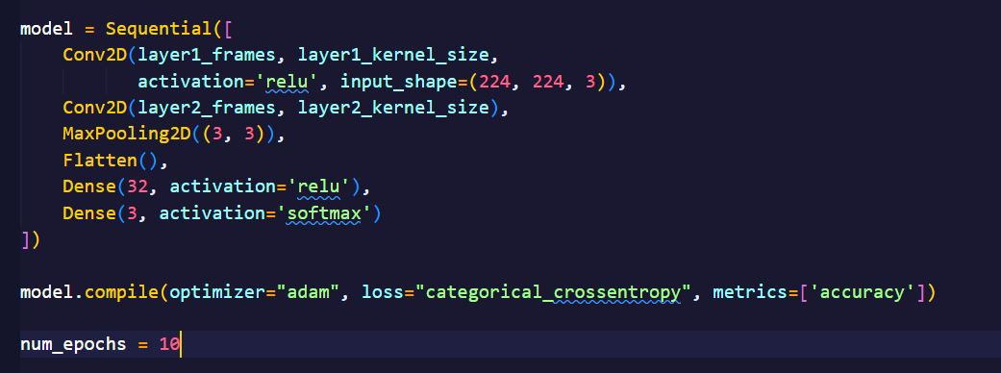

### **Results:**

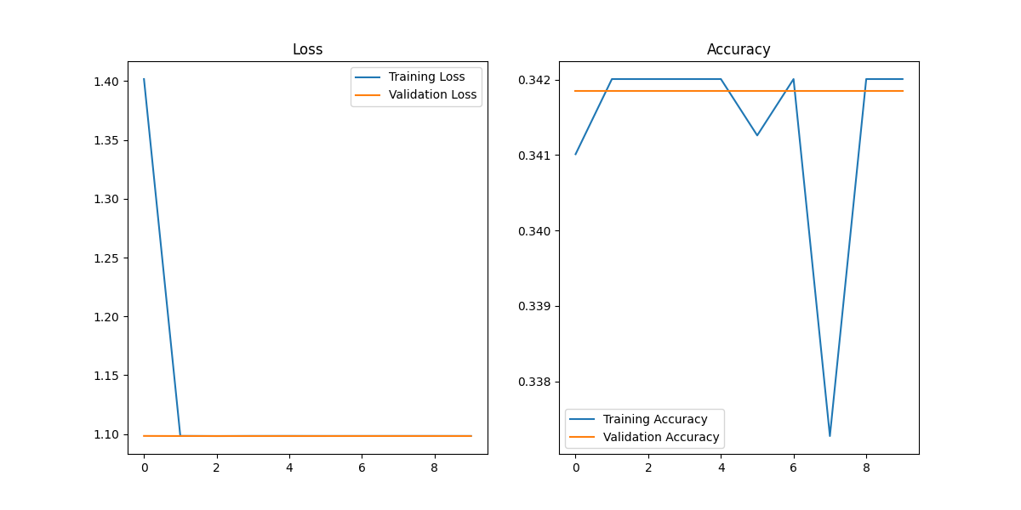

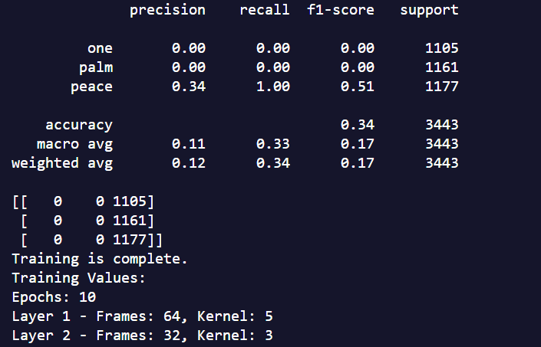

## **Test - 2 - Augmentation (wrong implementation)**

### **Structure:**

Conv2D(64, relu)

Conv2D(32)

MaxPool(3,3)

Flatten()

Dense(32, relu)

Dense(3, softmax)

CHANGE FROM PREVIOUS - 1000 Images with augmentation

### **Other Params:**

Image #: 1000

Epochs: 100

Optimizer: Adam

Loss: Categorical Crossentrpy

### **Results:**

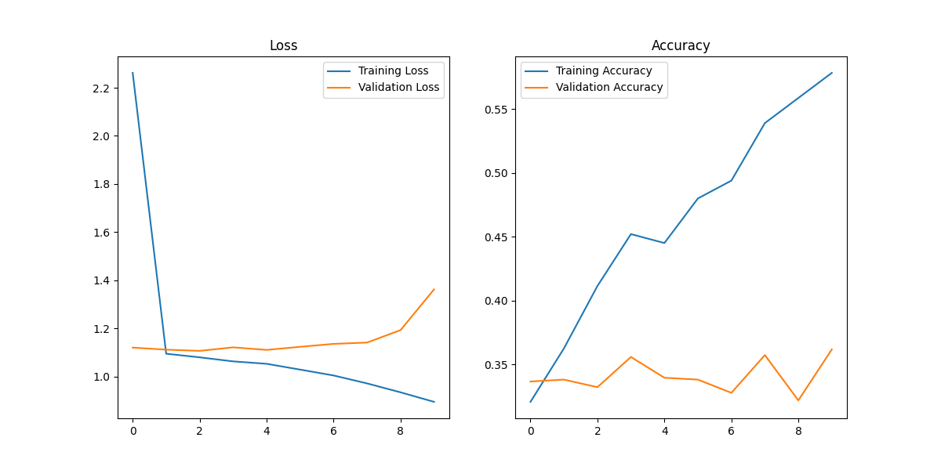

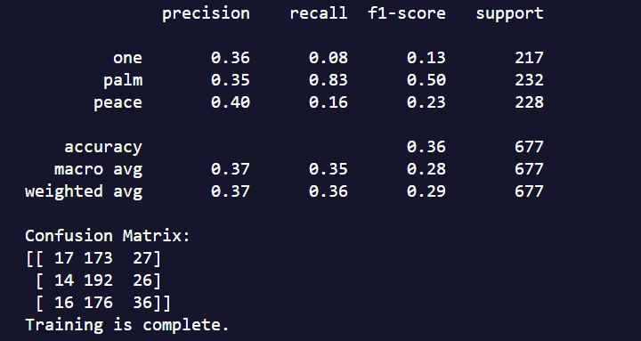

## Test - 3 - Batch Normalization - Wrong

### **Other Params:**

Image #: 1000

Epochs: 100

Optimizer: Adam

Loss: Categorical Crossentrpy

CHANGE FROM PREVIOUS - Batch Normalization

### **Structure:**

Conv2D(64, relu)

**BatchNormalization()**

Conv2D(32)

MaxPool(3,3)

Flatten()

Dense(32, relu)

Dense(3, softmax)

### 

### **Results:**

### **STOPPED RUN @ 50 Epochs, same results over and over and over.**

## Test - 4 - Batch Normalization - Fixed

### **Other Params:**

Image #: 1000

Epochs: 50

Optimizer: Adam

Loss: Categorical Crossentrpy

CHANGE FROM PREVIOUS - Batch Normalization

### **Structure:**

Conv2D(64, relu)

Conv2D(32)

MaxPool(3,3)

Flatten()

Dense(32)

**BatchNormalization()**

**Activation(‘relu’)**

Dense(3, softmax)

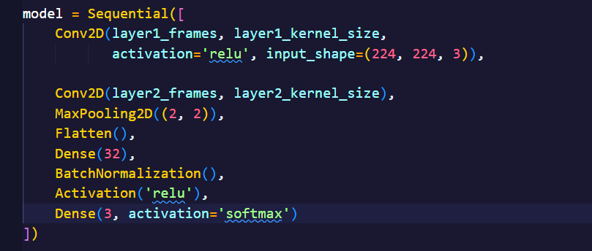

### 

### **Results: STOPPED WITH NO PROGRESS TOWARDS GETTING BETTER**

## Test - 5 - More layers + BatchNormal

### **Other Params:**

Image #: 1000

Epochs: 50

Optimizer: Adam

Loss: Categorical Crossentrpy

CHANGE FROM PREVIOUS - Batch Normalization

### **Structure:**

Conv2D(16, relu)

MaxPool(2,2)

Conv2D(32)

MaxPool(2,2)

Conv2D(64)

MaxPool(2,2)

Conv2D(128)

MaxPool(2,2)

Flatten()

Dense(32)

**BatchNormalization()**

**Activation(‘relu’)**

Dense(3, softmax)

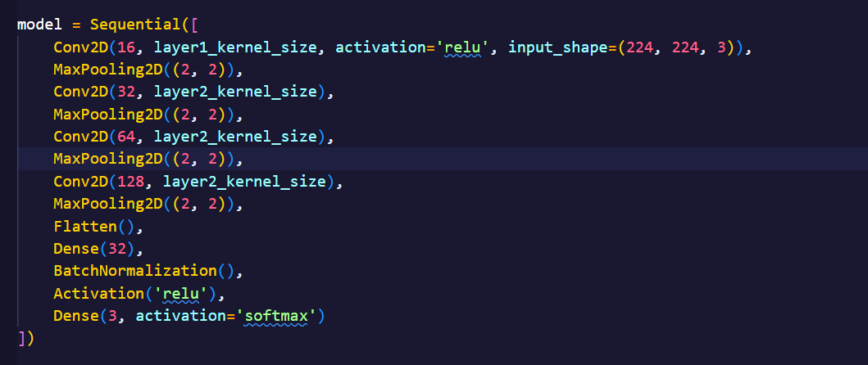

### 

### **Results:**

### **STOPPED WITH NO PROGRESS TOWARDS GETTING BETTER**

### **Test - 6 - Larger Dense - Same everything else from above**

### **Other Params:**

Image #: 1000

Epochs: 50

Optimizer: Adam

Loss: Categorical Crossentrpy

CHANGE FROM PREVIOUS - LARGER DENSE LAYER

### **Structure:**

Conv2D(16, relu)

MaxPool(2,2)

Conv2D(32)

MaxPool(2,2)

Conv2D(64)

MaxPool(2,2)

Conv2D(128)

MaxPool(2,2)

Flatten()

Dense(128)

**BatchNormalization()**

**Activation(‘relu’)**

Dense(3, softmax)

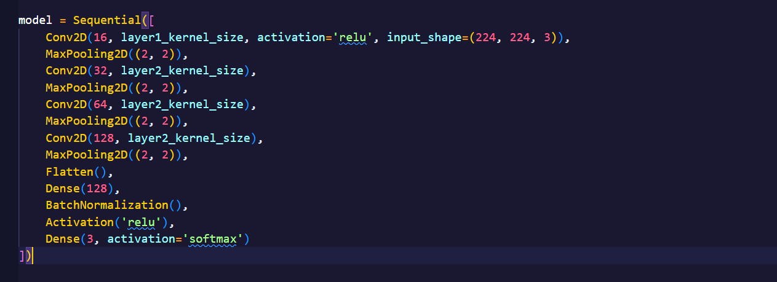

### **Results:**

### **STOPPED WITH NO PROGRESS TOWARDS GETTING BETTER**

**Test - 7 - Larger dataset - Same everything else from above**

### **Other Params:**

Image #: 3000

Epochs: 50

Optimizer: Adam

Loss: Categorical Crossentrpy

CHANGE FROM PREVIOUS - Larger dataset

### **Structure:**

Conv2D(16, relu)

MaxPool(2,2)

Conv2D(32)

MaxPool(2,2)

Conv2D(64)

MaxPool(2,2)

Conv2D(128)

MaxPool(2,2)

Flatten()

Dense(128)

**BatchNormalization()**

**Activation(‘relu’)**

Dense(3, softmax)

### **Results: STOPPED EARLY AS USUAL NO RESULTS**

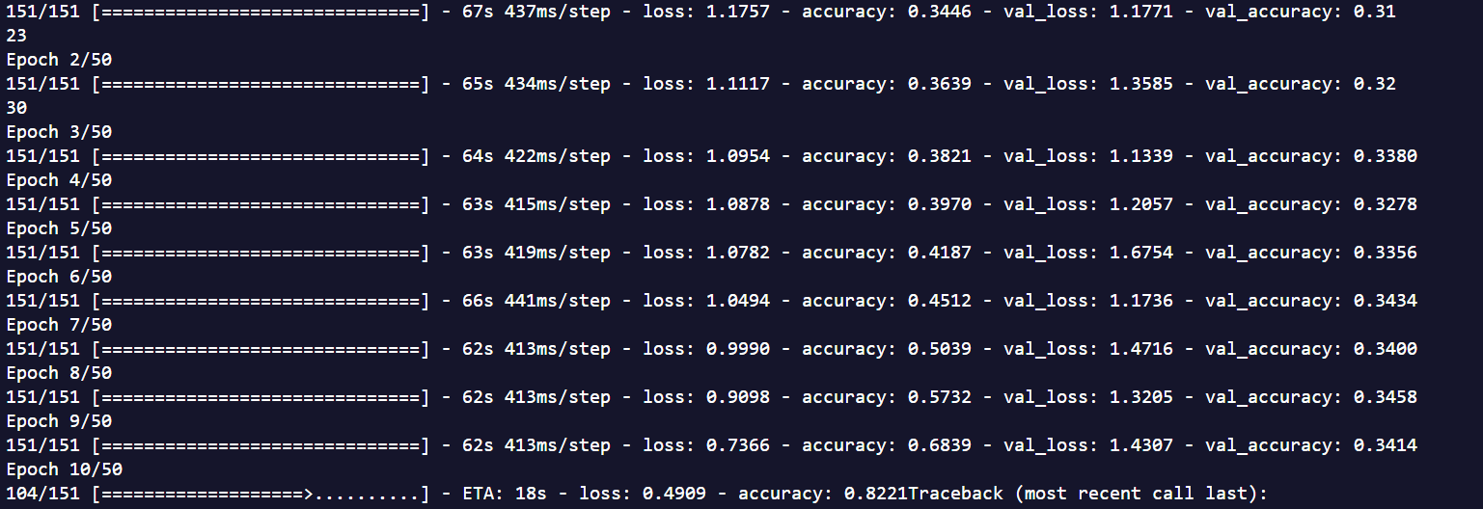

**Test - 8 - Larger dataset - Shrunk architecture**

### **Other Params:**

Image #: 3000

Epochs: 50

Optimizer: Adam

Loss: Categorical Crossentrpy

CHANGE FROM PREVIOUS - smaller architecture

### **Structure:**

Conv2D(16, relu)

MaxPool(2,2)

Conv2D(32)

MaxPool(2,2)

Conv2D(64)

MaxPool(2,2)

Flatten()

Dense(128)

**BatchNormalization()**

**Activation(‘relu’)**

Dense(3, softmax)

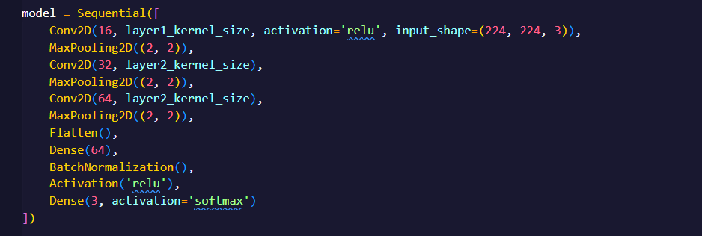

### **Results: STOPPED EARLY AS USUAL NO RESULTS**

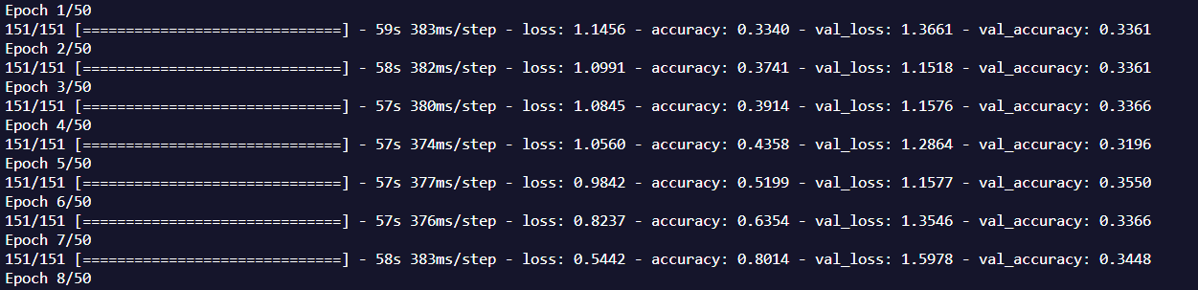

**Test - 8 - Larger dataset - Smaller Batch Size**

### **Other Params:**

Image #: 3000

Epochs: 50

Optimizer: Adam

Batch Size: 16

Loss: Categorical Crossentrpy

### **Structure:**

Conv2D(16, relu)

MaxPool(2,2)

Conv2D(32)

MaxPool(2,2)

Conv2D(64)

MaxPool(2,2)

Flatten()

Dense(128)

**BatchNormalization()**

**Activation(‘relu’)**

Dense(3, softmax)

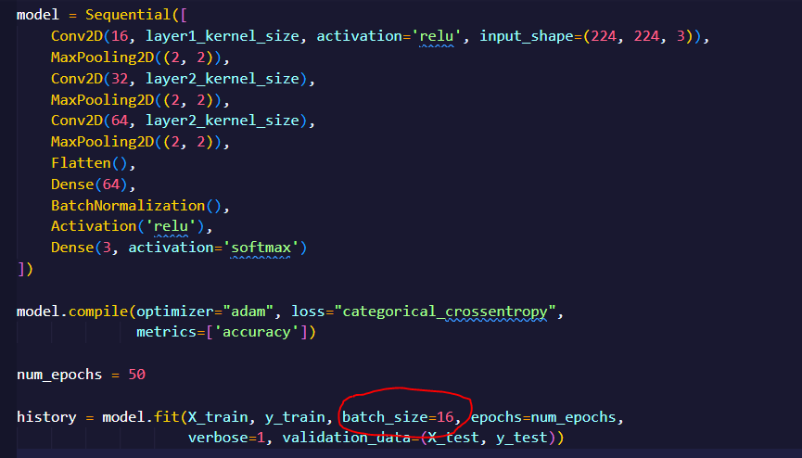

### **Results: STOPPED EARLY AS USUAL NO RESULTS (VAL LOSS INCREASING)**

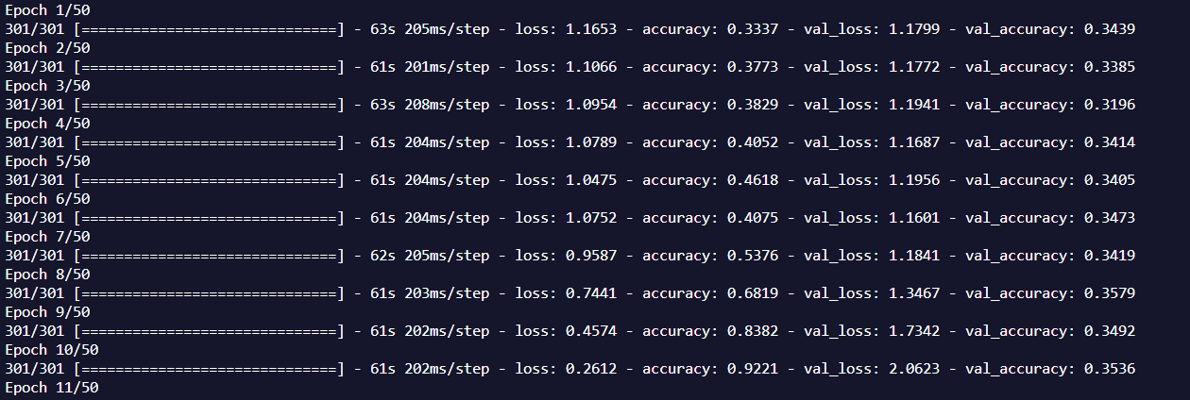

**Test - 8 - Remove BatchNorm - Add Dropout -**

### **Other Params:**

Image #: 3000

Epochs: 50

Optimizer: Adam

Loss: Categorical Crossentrpy

**Structure:**

Conv2D(16, relu)

MaxPool(2,2)

Conv2D(32)

MaxPool(2,2)

Dropout(.25)

Conv2D(64)

MaxPool(2,2)

Dropout(.25)

Flatten()

Dropout(.25)

Dense(128, relu)

Dense(3, softmax)

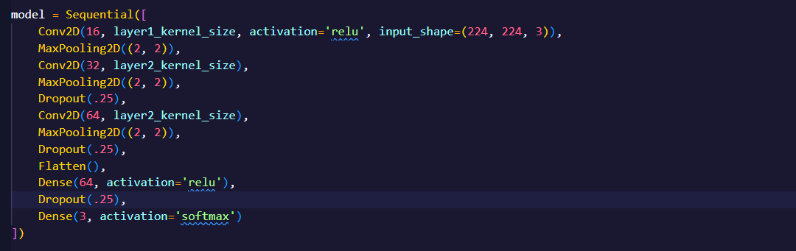

### **Results: STOPPED EARLY AS USUAL NO RESULTS (No Learning seemed to be occurring by epoch 15)**

**Test - 9 - Remove BatchNorm - Add Dropout - Grayscale**

### **Other Params:**

Image #: 3000

Epochs: 50

Optimizer: Adam

Loss: Categorical Crossentrpy

CHANGE FROM PREVIOUS - IMAGE TO GRAYSCALE

**Structure:**

Conv2D(16, relu)

MaxPool(2,2)

Conv2D(32)

MaxPool(2,2)

Dropout(.25)

Conv2D(64)

MaxPool(2,2)

Dropout(.25)

Flatten()

Dropout(.25)

Dense(128, relu)

Dense(3, softmax)



### **Results: STOPPED EARLY AS USUAL NO RESULTS (Validation Loss increasing)**

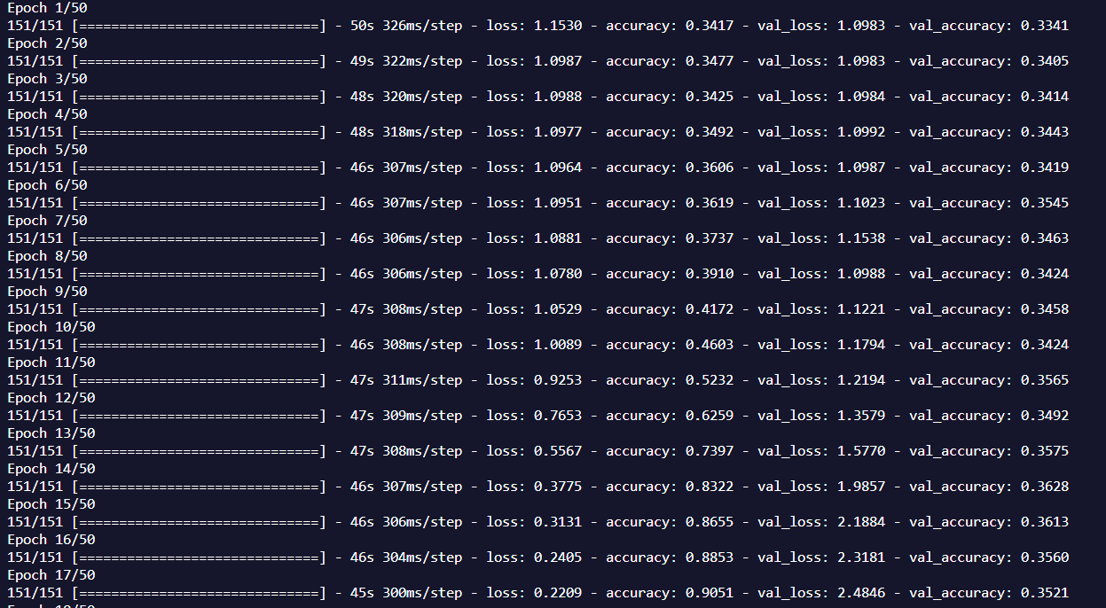

**Test - 10 - Increase batch size to 128**

### **Other Params:**

Image #: 5000

Epochs: 10

Batch size: 128

Optimizer: Adam

Loss: Categorical Crossentrpy

CHANGE FROM PREVIOUS - Padding across all - increased batch size

**Structure:**

Conv2D(16, relu)

MaxPool(2,2)

Conv2D(32)

MaxPool(2,2)

Conv2D(64)

MaxPool(2,2)

Flatten()

Dense(128, relu)

Dense(3, softmax)

### **Results: Seemed to be slowly getting better, going to run again with slightly smaller batch size**

**Test - 11 - Add many more layers**

### **Other Params:**

Image #: 5000

Epochs: 10

Batch size: 128

Optimizer: Adam

Loss: Categorical Crossentrpy

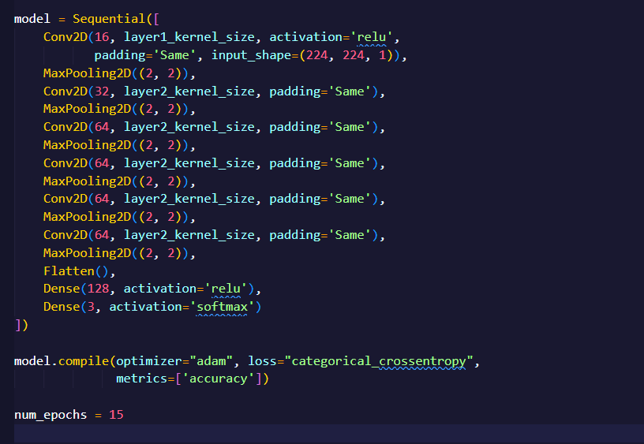

CHANGE FROM PREVIOUS - Added more layers!

**Structure:**

Conv2D(16, relu)

MaxPool(2,2)

Conv2D(32)

MaxPool(2,2)

Conv2D(64)

MaxPool(2,2)

Conv2D(64)

MaxPool(2,2)

Conv2D(64)

MaxPool(2,2)

Conv2D(64)

MaxPool(2,2)

Flatten()

Dense(128, relu)

Dense(3, softmax)

### **Results: MUCH BETTER!**

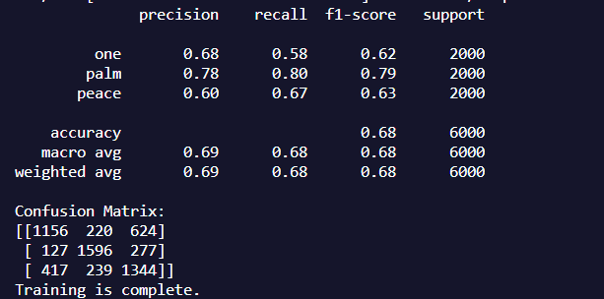

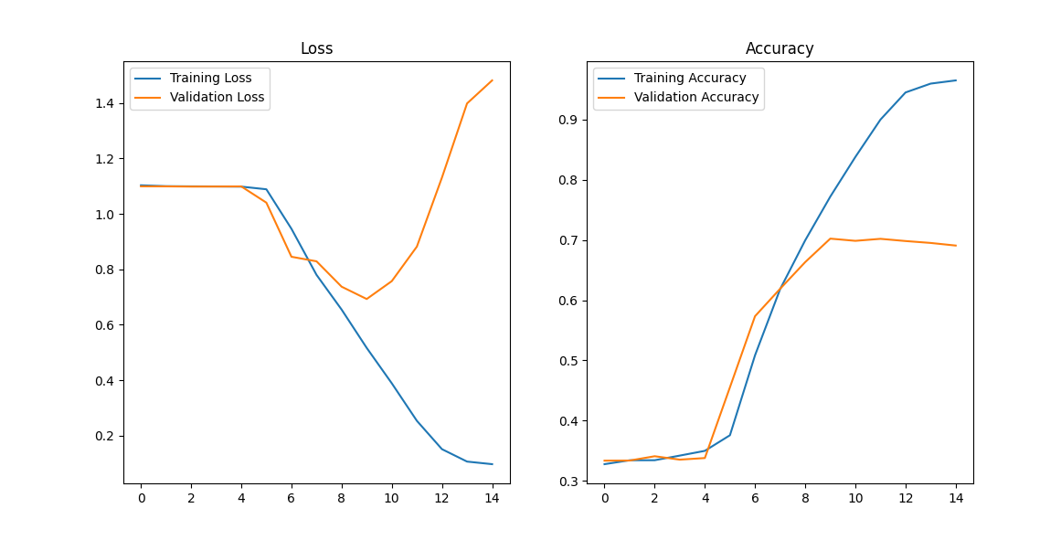

**Test - 11 - Smaller batch size**

### **Other Params:**

Image #: 5000

Epochs: 15

Batch size: 32

Optimizer: Adam

Loss: Categorical Crossentrpy

CHANGE FROM PREVIOUS - Lowered Batch Size

**Structure:**

Conv2D(16, relu)

MaxPool(2,2)

Conv2D(32)

MaxPool(2,2)

Conv2D(64)

MaxPool(2,2)

Conv2D(64)

MaxPool(2,2)

Conv2D(64)

MaxPool(2,2)

Conv2D(64)

MaxPool(2,2)

Flatten()

Dense(128, relu)

Dense(3, softmax)

### **Results:Similar to Previous run**

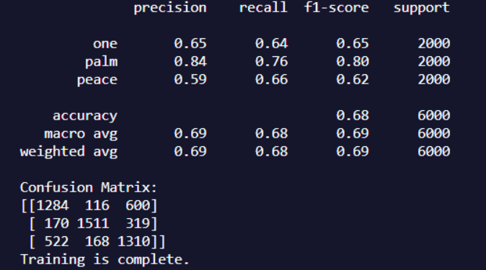

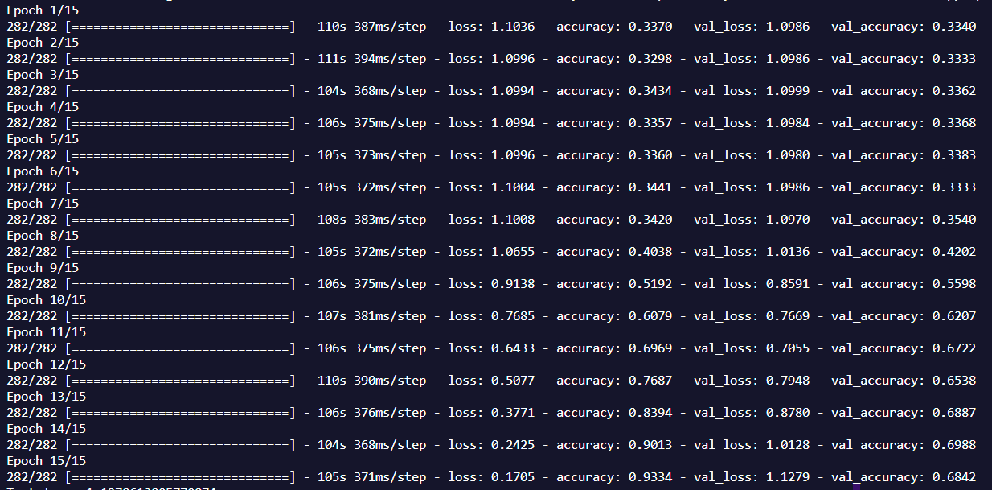

**Test - 12 - MORE IMAGES!**

**Other Params:**

Image #: 8000

Epochs: 15

Batch size: 64

Optimizer: Adam

Loss: Categorical Crossentrpy

CHANGE FROM PREVIOUS - Added 3000 images per class

**Structure:**

Conv2D(16, relu)

MaxPool(2,2)

Conv2D(32)

MaxPool(2,2)

Conv2D(64)

MaxPool(2,2)

Conv2D(64)

MaxPool(2,2)

Conv2D(64)

MaxPool(2,2)

Conv2D(64)

MaxPool(2,2)

Flatten()

Dense(128, relu)

Dense(3, softmax)

### **Results:Similar to Previous run**

